**Generating Rich People Data and Corresponding Wealth Statistics in an SQLite Database**

**Student Name: Abhishek Aeera**

**Student Id: 22097107**

**GitHub:** [**https://github.com/AbhishekAeera/Richest-people**](https://github.com/AbhishekAeera/Richest-people)

**Introduction:**

In this project, we delve into the realm of data simulation and database management to construct a comprehensive dataset focusing on the world's wealthiest individuals and their corresponding wealth statistics. Leveraging Python and SQLite, we embark on the task of generating synthetic data to populate two distinct tables within our database: "Richest People" and "Wealth Statistics”. The "Richest People" table encapsulates a plethora of information about affluent individuals, encompassing attributes such as their names, ages, net worth, sources of wealth, citizenships, and industries they belong to. On the other hand, the "Wealth Statistics" table aggregates pertinent data related to different wealth categories, providing insights into the average worth, total population, highest and lowest worth, dominant nationalities, and most common industries associated with these categories. By simulating this dataset, we lay the foundation for an analytical exploration into the intricate dynamics of wealth distribution and wealth creation across various demographic and economic dimensions. Through this project, we not only showcase proficiency in data generation and database management but also demonstrate the potential of synthesized datasets for insightful analysis and decision-making.

**Data Generation.**

The primary objective of this data generation process is to create a simulated dataset that mimics real-world data pertaining to wealthy individuals and wealth statistics. This dataset will serve as a foundation for analytical exploration and decision-making processes.

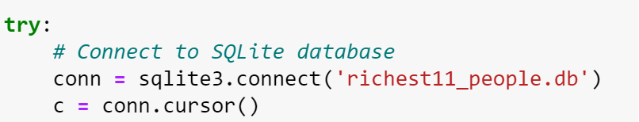

We generated synthetic data for wealthy individuals using Python's random module. Attributes such as name, age, net worth, source of wealth, citizenship, and industry were simulated. Random names were generated by combining prefixes and suffixes. Age was generated using random integers within a specified range. Net worth was simulated as a random float within a predefined range, representing billions of dollars. Source of wealth, citizenship, and industry were randomly chosen from predefined lists.

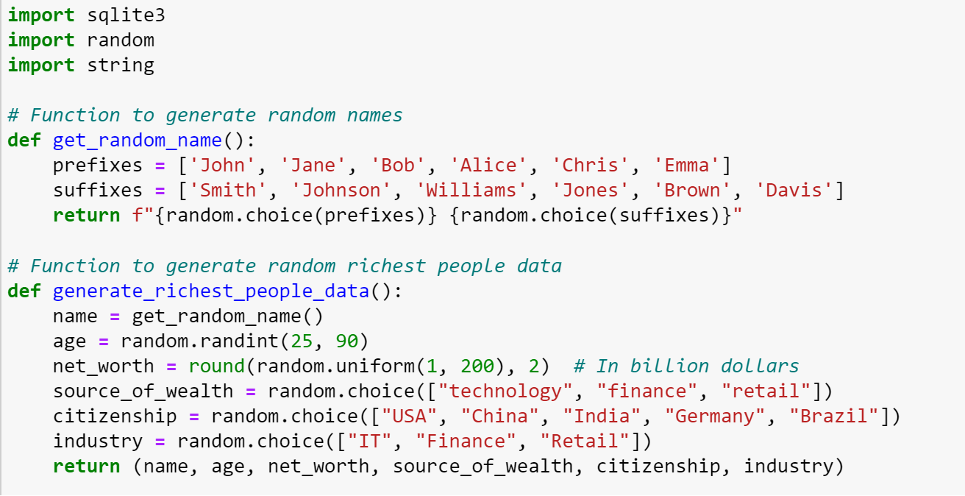

Data for wealth statistics was generated to provide insights into various wealth categories. Wealth categories were randomly generated using a combination of uppercase letters. Wealth categories were randomly generated using a combination of uppercase letters. Data for each category was generated uniquely to avoid duplicates.

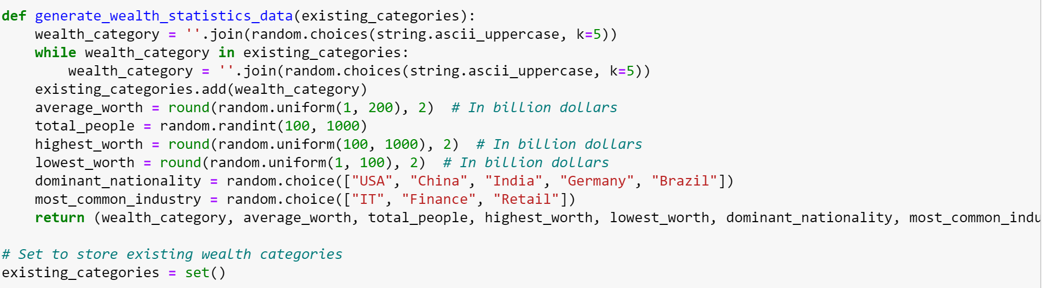

Ensuring uniqueness: To prevent duplicate entries, particularly in the Wealth Statistics table, we implemented checks to ensure that each wealth category is unique. Balancing randomness: While randomness is essential for creating realistic data, ensuring a balance between randomness and coherence was crucial to generate meaningful insights. The data generation process successfully created a dataset containing 1000 records for both the Richest People and Wealth Statistics tables. The dataset provides a diverse representation of wealthy individuals and wealth categories, enabling comprehensive analysis and exploration. Incorporating more attributes: Future iterations of the data generation process could include additional attributes for richer analysis, such as geographic location, education level, or philanthropic activities. Refinement of randomness: Fine-tuning the randomness parameters could lead to more nuanced and realistic datasets. Integration with real-world data: Combining simulated data with real-world datasets could provide deeper insights and enhance the dataset's applicability in various domains.

The data generation process successfully achieved its objectives by creating a comprehensive and diverse dataset for wealthy individuals and wealth statistics. This dataset serves as a valuable resource for analytical exploration and decision-making across various domains, laying the groundwork for further research and analysis in the field of wealth distribution and economics.

**Database Schema**

The database schema outlines the structure of the database, including tables, their attributes, and relationships between them. Here's the schema for the "Richest People" database:

Richest people Data Table:

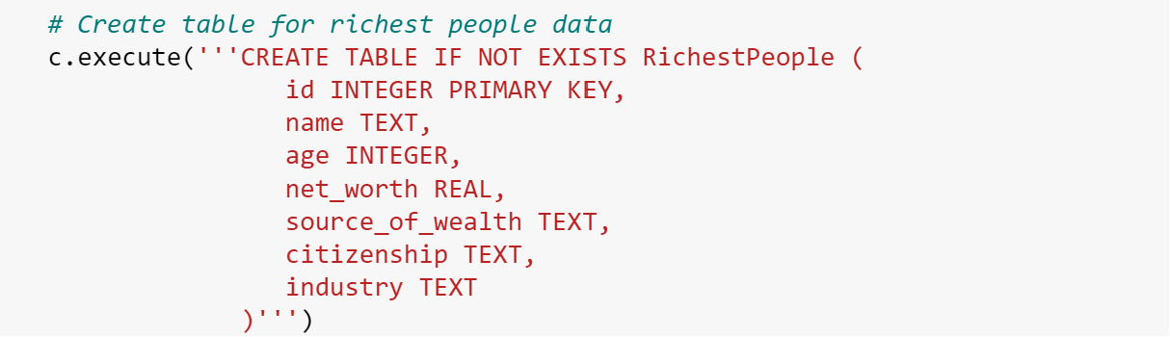

* id: INTEGER (Primary Key)
* name: TEXT
* age: INTEGER
* net worth: REAL
* source_of_wealth: TEXT
* citizenship: TEXT
* industry: TEXT

**Wealth Statistics Table:**

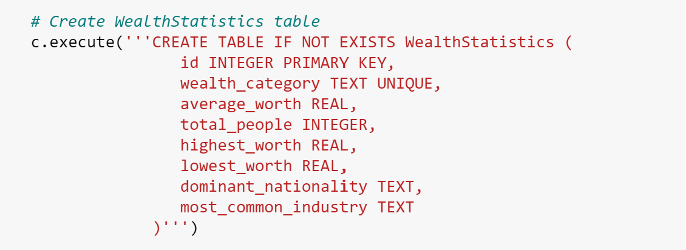

* id: INTEGER (Primary Key)
* wealth_category: TEXT (Unique)
* average_worth: REAL
* total_people: INTEGER
* highest_worth: REAL
* lowest_worth: REAL
* dominant_nationality: TEXT
* most_common_industry: TEXT

The **RichestPeople** table stores information about wealthy individuals, including their name, age, net worth, source of wealth, citizenship, and industry. The **WealthStatistics** table contains statistics related to various wealth categories. Each category is uniquely identified by its wealth_category attribute and includes information such as average worth, total number of people, highest and lowest worth, dominant nationality, and most common industry. There are no explicit relationships defined between the tables in this schema. However, both tables provide complementary information about wealth distribution, and analytical queries can be performed to derive insights from the combined dataset.

**Justification and Ethical Discussion**

Separating tables allows for better management of sensitive information, such as personal details of individuals in the "RichestPeople" table. Ethical considerations dictate that this data must be securely stored and accessed only by authorized personnel to prevent privacy breaches or misuse. Maintaining separate tables promotes transparency in data handling practices. It enables clear identification of data sources and facilitates accountability in data management procedures. Ethical guidelines require organizations to maintain accurate records and ensure transparency in reporting practices. Separating data into distinct categories helps mitigate biases and promotes fairness in analysis and decision-making processes. By analyzing aggregated wealth statistics separately from individual profiles, organizations can identify disparities and address potential biases in their wealth distribution models. Ethical data practices emphasize the importance of informed consent when collecting and using personal data. By segregating data into separate tables based on their intended use, organizations can provide clearer explanations to individuals regarding how their data will be utilized and seek appropriate consent for each purpose. In summary, the justification for separate tables lies in their ability to organize data effectively, support scalability and optimize query performance. Ethical considerations focus on safeguarding data privacy, promoting transparency and accountability, mitigating biases, and ensuring informed consent, thereby upholding ethical standards in data management practices.

**Example Queries:**

Query 1:

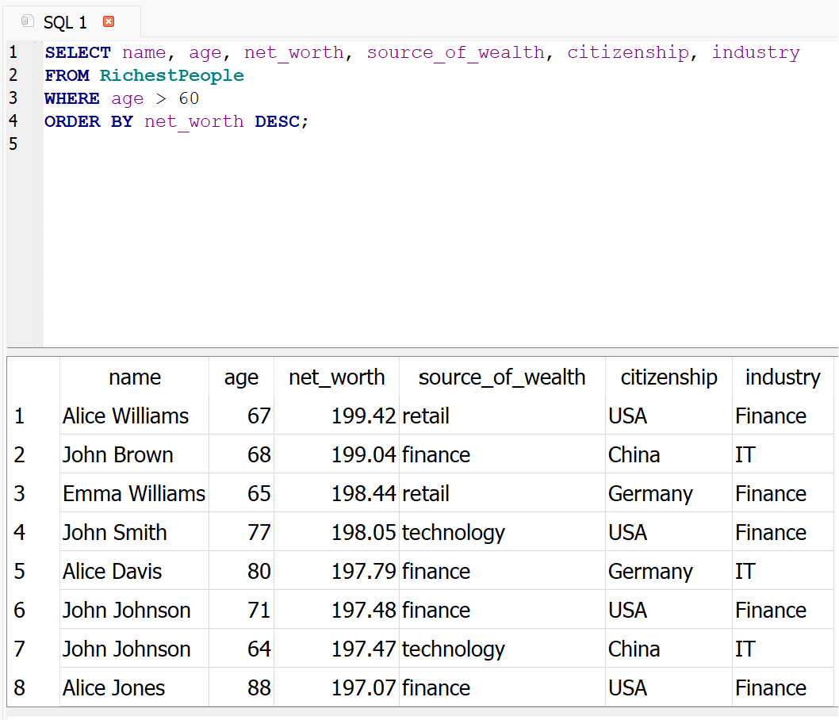

Executing this query provides insights into the demographics of wealthy individuals who are above the age of 60. By filtering based on age and sorting by net worth, we can identify older individuals who have accumulated significant wealth. This information can be valuable for various purposes, such as market research, financial planning, or demographic analysis.

Furthermore, this query demonstrates the capability of SQL to handle different data types, including text (name, source_of_wealth, citizenship, industry), numerical (age, net worth), and sorting based on numeric values (net worth). Additionally, the query showcases the use of selection criteria (age > 60) and ordering (ORDER BY net worth DESC) to retrieve specific subsets of data and present it in a meaningful manner.

Query 2:

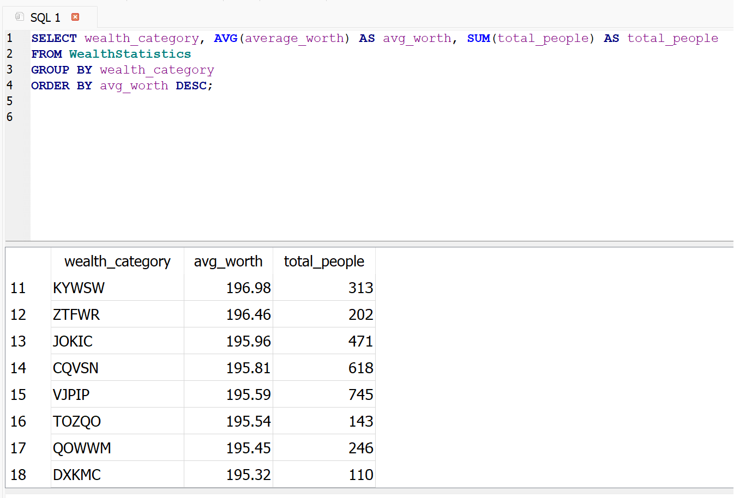

Executing this SQL query provides insights into the average net worth and total number of people belonging to different wealth categories. By grouping the data by wealth category and calculating the average net worth and sum of total people within each category, we can analyse the distribution of wealth across various segments of the population. The results are ordered in descending order based on the average net worth within each wealth category. This allows us to identify the categories with the highest average net worth, providing valuable information for understanding wealth distribution patterns. This query demonstrates the power of SQL in performing aggregate functions such as AVG() and SUM(), along with grouping data using GROUP BY. It enables us to summarize and analyze large datasets efficiently, facilitating decision-making processes in various fields such as economics, sociology, and finance.

Query 3:

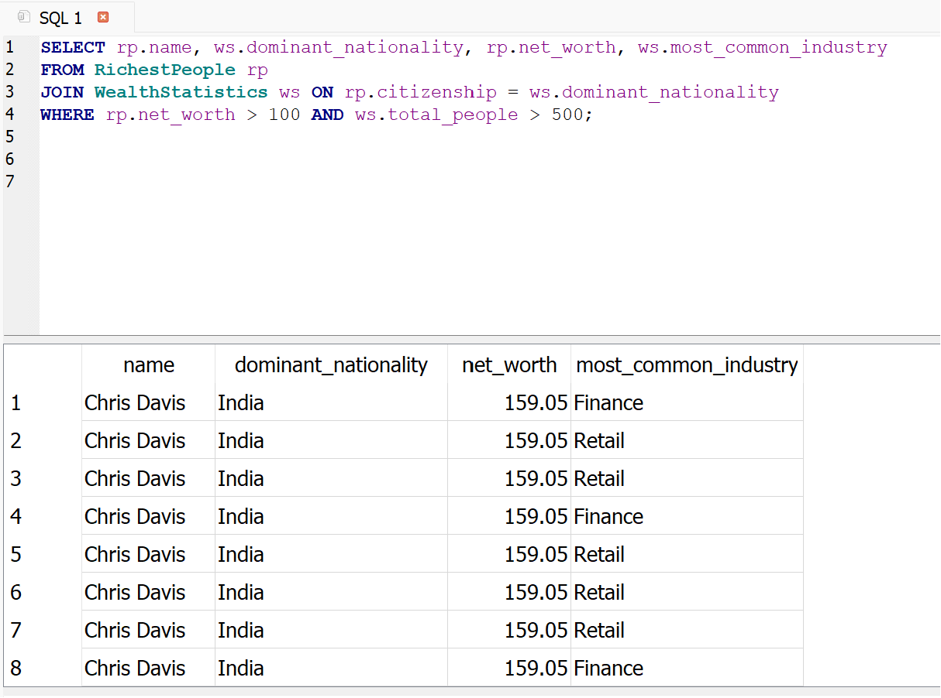

Executing this SQL query provides a comprehensive overview of wealthy individuals who share a common nationality with the dominant nationality in their respective wealth category. The query retrieves data from both the richest People and wealth Statistics tables, joining them based on the citizenship of the individuals and the dominant nationality in the wealth statistics.The results include the name of the wealthy individual, their nationality, net worth, and the most common industry associated with their wealth category. By filtering the results to include only individuals with a net worth greater than $100 billion and wealth categories with more than 500 people, we focus on significant individuals and statistically relevant wealth categories.This query demonstrates the use of SQL joins to combine data from multiple tables based on a common attribute, allowing for more complex and insightful analysis. It provides valuable information for understanding the relationship between nationality, industry, and wealth distribution, contributing to broader discussions on socioeconomic factors and global wealth disparities.

Query 4:

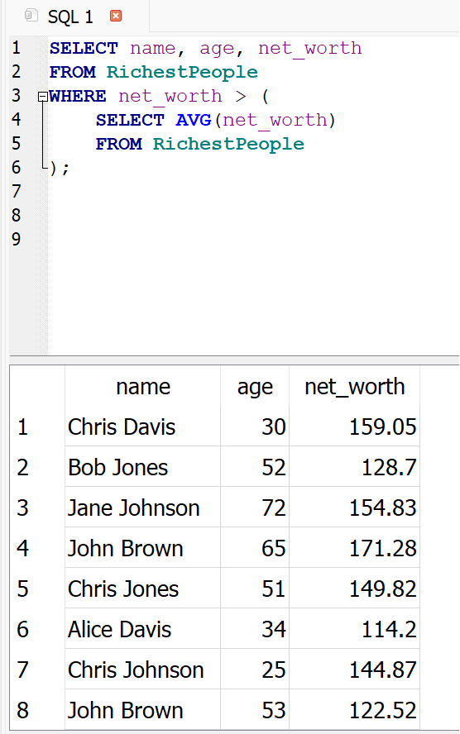

The SQL query selects the names, ages, and net worth of individuals from the richest People table whose net worth exceeds the average net worth of all individuals in the same table. Utilizing a subquery within the WHERE clause, the average net worth is calculated dynamically, allowing for a comparison against individual net worth values. This query enables the identification of individuals whose wealth surpasses the average within the dataset, potentially highlighting outliers or exceptionally affluent individuals. Such analysis could be valuable for identifying trends, outliers, or conducting further investigation into the factors contributing to extreme wealth accumulation. By leveraging SQL's subquery capabilities, this query demonstrates the versatility of SQL in performing complex data analysis tasks within relational databases. It provides insights into the distribution of wealth within the dataset and aids in understanding the characteristics of individuals with significant net worth.

**Conclusion:**

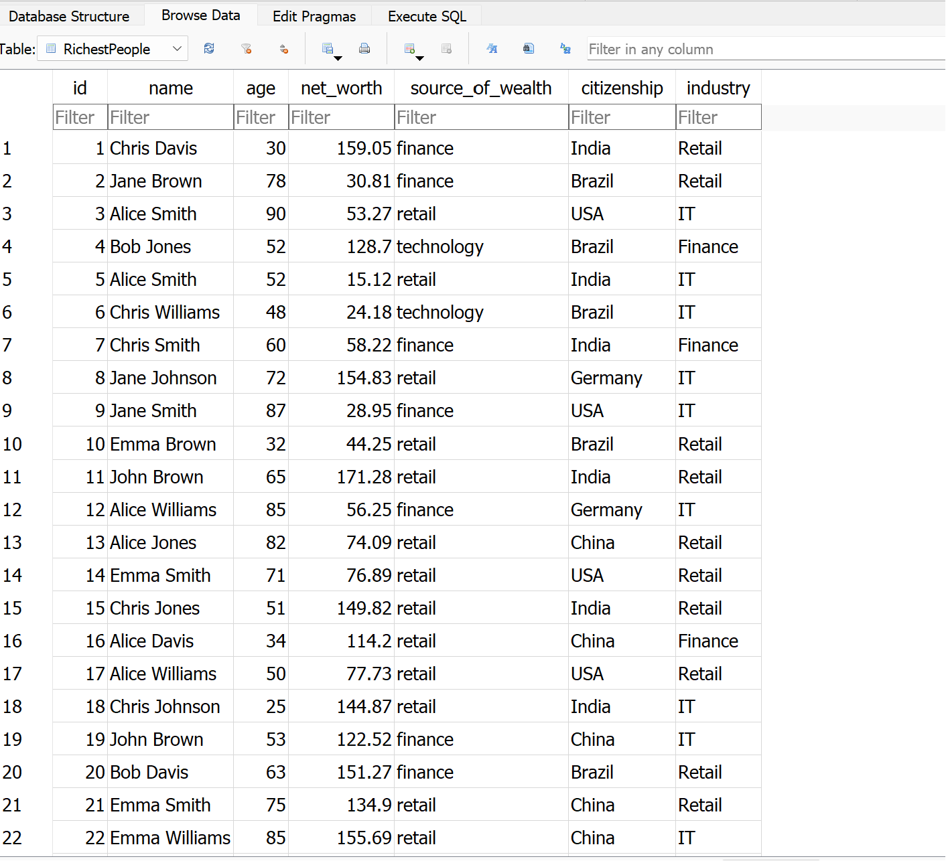

**Conclusion:**

This table stores information about 1000 individuals, including their name, age, net worth, source of wealth, citizenship, and industry. The data is randomly generated to simulate a diverse population of wealthy individuals.

This table contains statistics related to wealth distribution, with each row representing a different wealth category. The statistics include the average net worth, total number of people, highest net worth, lowest net worth, dominant nationality, and most common industry within each wealth category. This data is also randomly generated.

The generated database can be used for various purposes such as statistical analysis, trend identification, and research on wealth distribution and its associated factors. By simulating diverse data, it provides a foundation for exploring patterns and correlations within the wealth landscape.

Overall, the code demonstrates the process of generating synthetic data and populating a SQLite database, which can serve as a valuable resource for further analysis and investigation in the realm of wealth distribution and related socio-economic phenomena.